C2. Not So Simple Polygon Embedding
time limit per test
2 seconds
memory limit per test
256 megabytes
input
standard input
output
standard output
The statement of this problem is the same as the statement of problem C1. The only difference is that, in problem C1, nn is always even, and in C2, nn is always odd.
You are given a regular polygon with 2⋅n2⋅n vertices (it's convex and has equal sides and equal angles) and all its sides have length 11. Let's name it as 2n2n-gon.
Your task is to find the square of the minimum size such that you can embed 2n2n-gon in the square. Embedding 2n2n-gon in the square means that you need to place 2n2n-gon in the square in such way that each point which lies inside or on a border of 2n2n-gon should also lie inside or on a border of the square.
You can rotate 2n2n-gon and/or the square.
Input
The first line contains a single integer TT (1≤T≤2001≤T≤200) — the number of test cases.
Next TT lines contain descriptions of test cases — one per line. Each line contains single odd integer nn (3≤n≤1993≤n≤199). Don't forget you need to embed 2n2n-gon, not an nn-gon.
Output
Print TT real numbers — one per test case. For each test case, print the minimum length of a side of the square 2n2n-gon can be embedded in. Your answer will be considered correct if its absolute or relative error doesn't exceed 10−610−6.
Example
input
Copy
3
3
5
199
output
Copy
1.931851653
3.196226611
126.687663595

n是偶数的时候比较水。。
然后n是奇数的时候。是要旋转一定角度卡进那个正方形里面的。。
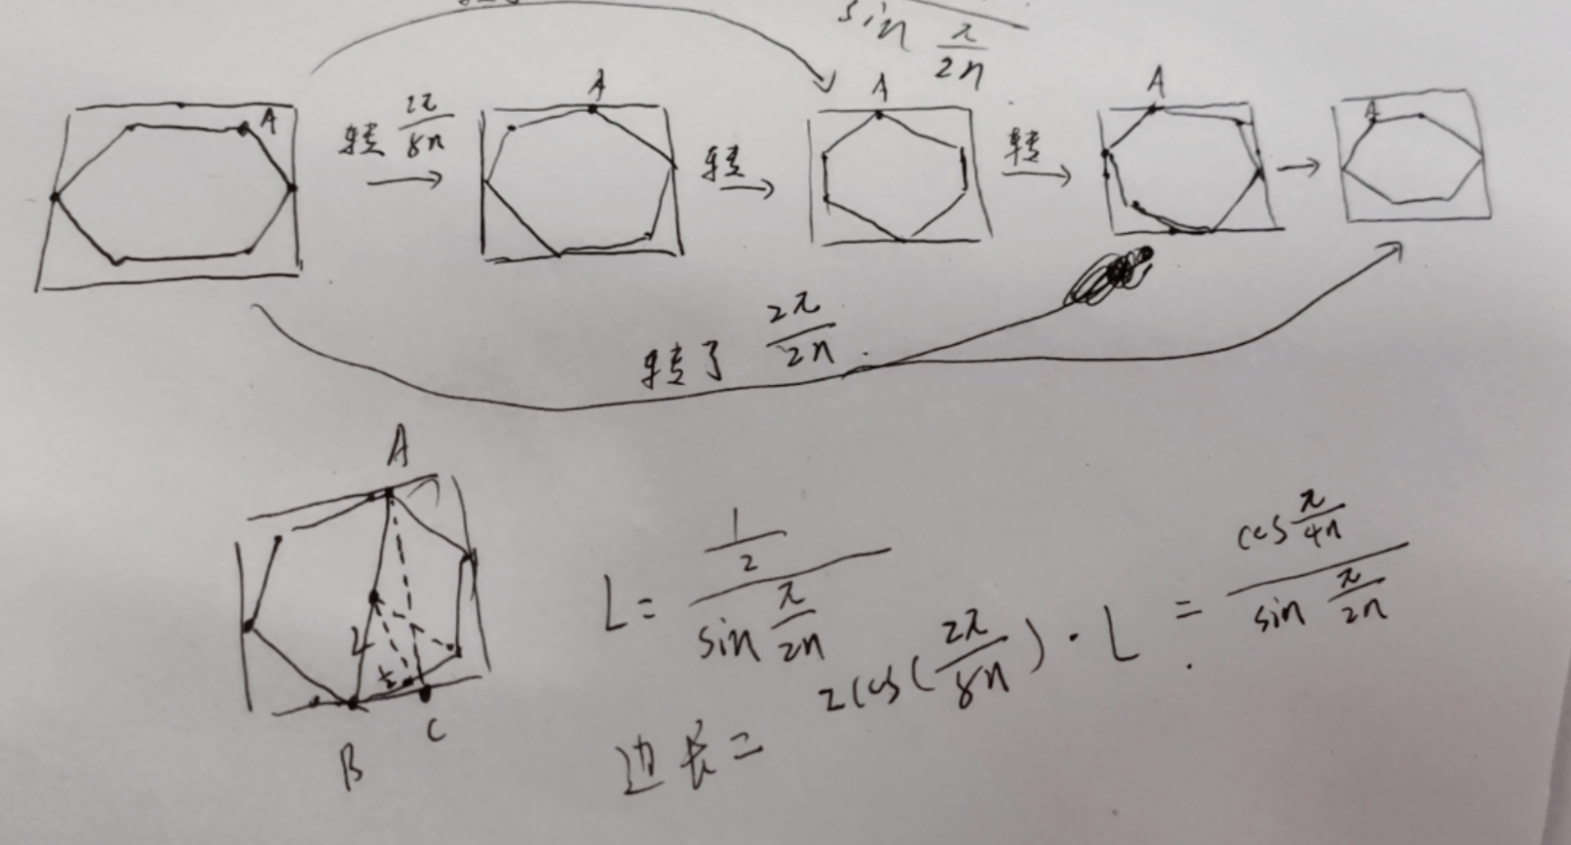

#include<bits/stdc++.h>
#define ll long long
using namespace std;
int main()
{
double PI=acos(-1.0);
int t;
scanf("%d",&t);
while(t--)
{
int n;
scanf("%d",&n);
double ans;
ans=cos(PI/(4*n))/sin(PI/(2*n));
printf("%lf\n",ans);
}
return 0;
}

